**Algebra 3-4**

**Unit 2: Functions, Equations, and Graphs**

Designer(s): OPS Secondary Math Department Grade Level: Algebra 3-4, 2013

Functions, Equations, and Graphs

Unit Overview

You can use functions to model all kinds of real-world situations. A function can model something as simple as a line between two points or as complex as the curves of a roller coaster. You will learn how to work with functions in this chapter.

|  |  |  |
| --- | --- | --- |
| **Functions, Equations, and Graphs** | | |
| **Essential Questions** | **Standard** | **Objectives**  F= Factual C=Conceptual D=Debatable |
| * 1. Does it matter which form of a linear equations you use? | 12.3.1b, c, e, g, i | * Students will identify different forms of linear equations (F) * Students will determine which form of a linear equation is most easily found with the given transformation (C) * Students will convert between various forms of linear equations (C) |
| * 1. How do you use transformations to help graph absolute value functions? | 12.3.1b, c, e, g, i | * Students will identify the different kinds of transformations (F) * Students will determine whether a transformation changes the location or shape of a graph or both (C) |
| * 1. How can you model data with a linear function? | 12.4.1f | * Students will make a scatter plot of linear data (C) * Students will determine the correlation of linear data (C) * Students will use linear regression to find the line of best fit of linear data (C) |

**Functions, Equations, and Graphs**

**Critical Content and Skills:**

|  |  |
| --- | --- |
| *Knowledge Statements*  Students will know…   1. **Vocabulary**: relation, domain, range, function, direct variation, slope, linear equation, correlation 2. Slope-intercept, Point-slope and Standard Form of an equation 3. Transformations of graphs, 4. Graphing Inequalities | *Key Skill Statements*  Students will know how to…   1. Graph a linear function from any form 2. Graph the transformation of a function from a parent 3. Graph linear inequalities in two variables |

|  |  |  |  |
| --- | --- | --- | --- |
| **Algebra 3-4**  **Chapter 2 Functions, Equations, and Graphs** | | | |
| **Advanced**  **Score 4.0** | In addition to the Proficient (3.0) performance, makes ***indepth*** inferences and extended applications of what was learned, including connections to other experiences. | | * Using a found equation for line of best fit to estimate future events * Compare two transformed, non-linear functions |
|  | **Proficient +**  **Score 3.5** | In addition to the complex ideas and processes (Proficient 3.0) performance, ***partial success*** at in-depth inferences and extended applications of what was learned, including connections to other experiences. | |
| **Proficient**  **Score 3.0** | ***No major*** errors or omissions regarding any of the information and simple (Basic, 2.0) or complex processes (Proficient, 3.0) that was explicitly taught. | | * Solve problems applying direct variation * Graphing a line from Standard Form * Writing an equation of a line using point-slope form, or slope intercept form where *m* and/or *b* are not given * Writing the equation of a line in Standard Form * Graph a transformed, non-linear function * Writing the equation of a non-linear, transformed function * Graphing a two-variable inequality |
|  | **Basic +**  **Score 2.5** | ***No major*** errors or omissions regarding any of the information and/or simpler details and processes (Basic, 2.0) and ***partial*** knowledge of the more complex ideas and processes (Proficient, 3.0) | |
| **Basic**  **Score 2.0** | ***No major*** errors or omissions regarding the simpler details and processes (Basic, 2.0), but ***major*** errors or omissions regarding the more complex ideas and processes (Proficient, 3.0). | | * Identify domain and range of a relation * Determine if a relation is a function * Evaluate a function for a given *x*-value * Determine if a function shows direct variation and write the function rule * Using a proportion to solve direct variation * Graphing a line from slope-intercept form * Writing the equation of a line in slope-intercept form given *m* and *b* * Make a scatter plot and describe correlation |
| **Below Basic**  **Score 1.0** | A ***partial*** understanding of ***some*** of the simpler details and processes (Basic, 2.0), but ***major*** errors or omissions regarding the more complex ideas and processes. | | |
| **Failing**  **Score 0** | ***No*** evidence or ***insufficient*** evidence of student learning. | | |

Algebra 3 Name

Pd Date

**Chapter 2 Test**

Calculators are not permitted. Write answers in the blanks provided. Show all necessary work.

**1. Find the domain and range of the relation, then determine whether it is a function. (L2)**

$\left\{\left(2, 1\right), \left(-4, 5\right), \left(1, 7\right), \left(2, -3\right), \left(-1, 2\right)\right\}$

**Domain:**

**Range:**

**Function?**

**2. Evaluate the function for the given value of *x*. (L2)**

$f\left(x\right)=\frac{1}{4}x-6 for x=-8$

**2.**

**Suppose $f\left(x\right)=3x-4$ and $g\left(x\right)=\left|x\right|+2$. Find each value. (L2)**

**3. $f\left(\frac{1}{3}\right)+g\left(-2\right)$ 4. $\frac{f\left(1\right)}{g\left(1\right)}$**

**3. 4.**

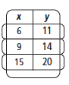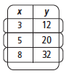**For each function, determine whether *y* varies directly with *x*. If so, find the constant of variation and write the function rule. (L2)**

**5. 6.**

**5. 6.**

**7. When $y=2$, $x=6$. Find $y$ when $x=\frac{3}{4}$. (L2)**

**7.**

**8. The diameter of a tree varies directly with its age. A 15-year-old tree has a 3.75 in. diameter. How old will the tree be when it has a 25 in diameter?(L3)**

**8.**

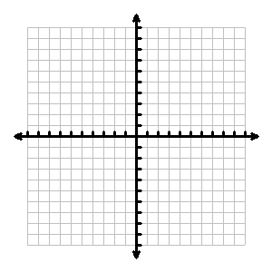

**9. Graph: $4x-3y=-2$ (L3)**

**Using slope-intercept form, write the equation of the line with the given characteristics. (L3)**

**10.** through $\left(1, 5\right) and \left(-3, 3\right)$**11.** Perpendicular to $y=\frac{3}{2}x+\frac{1}{4}$ and through $\left(3, 1\right)$

**10. 11.**

**12. Using point-slope form, write the equation of the line through $\left(5, 8\right)$ and $\left(0, -2\right)$. (L3)**

**12.**

**13. Using standard form, write the equation of the line with slope = 6 and through the point $\left(\frac{1}{2}, 2\right)$. (L3)**

**13.**

**Describe the translation then graph the function. (L3)**

**14. $y=-\left|x-4\right|$ 15. $y=\left|2x-1\right|+3$**



**16. Write the function rule $g\left(x\right)$ for the given transformations applied to the graph of $f\left(x\right)=x^{2}$. (L3)**

**4 units down, 1 unit left**

**16.**

**17. Write two absolute value functions such that they have a common vertex in Quadrant III and one is the reflection of the other over a horizontal line. (L4)**

**17.**



**18. Graph the inequality: $2x+3y≥-6$**  (L3)

**The table shows the enrollment at Coolsville High during the years 2004-2009.**

|  |  |  |  |  |  |  |
| --- | --- | --- | --- | --- | --- | --- |
| **Enrollment** | | | | | | |
| **Year** | 2004 | 2005 | 2006 | 2007 | 2008 | 2009 |
| **Enrollment** | 1582 | 1635 | 1674 | 1723 | 1745 | 1801 |

**19. Make a scatter plot of the data and draw a trend line. Let *x* = the number of years since 2003. (L2)**



**20. Write the equation of the line of best fit. (L3)**

**21. Estimate the enrollment in 2015. (L4)**

Algebra 3 Name

Pd Date

**Chapter 2 Test**

Calculators are not permitted. Write answers in the blanks provided. Show all necessary work.

**1. Find the domain and range of the relation, then determine whether it is a function. (L2)**

$\left\{\left(2, 1\right), \left(-4, 5\right), \left(1, 7\right), \left(2, -3\right), \left(-1, 2\right)\right\}$

**Domain: -4, -1, 1, 2**

**Range: -3, 1, 2, 5, 7**

**Function? no**

**2. Evaluate the function for the given value of *x*. (L2)**

$f\left(x\right)=\frac{1}{4}x-6 for x=-8$

**2. -8**

**Suppose $f\left(x\right)=3x-4$ and $g\left(x\right)=\left|x\right|+2$. Find each value. (L2)**

**3. $f\left(\frac{1}{3}\right)+g\left(-2\right)$ 4. $\frac{f\left(1\right)}{g\left(1\right)}$**

**3. 1 4. $-\frac{1}{3}$**

**For each function, determine whether *y* varies directly with *x*. If so, find the constant of variation and write the function rule. (L2)**

**5. 6.**

**5. y=4x 6. Not direct variation**

**7. When $y=2$, $x=6$. Find $y$ when $x=\frac{3}{4}$. (L2)**

**7. $\frac{1}{4}$**

**8. The diameter of a tree varies directly with its age. A 15-year-old tree has a 3.75 in. diameter. How old will the tree be when it has a 25 in diameter?(L3)**

**8. 100 years**

**9. Graph: $4x-3y=-2$**

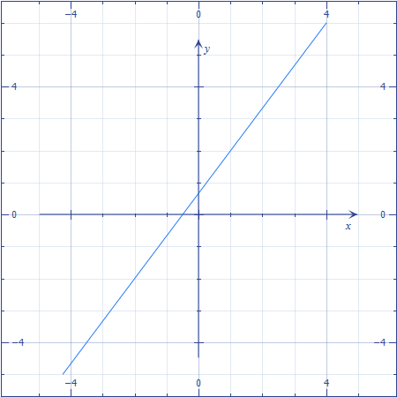 **(L3)**

**Using slope-intercept form, write the equation of the line with the given characteristics. (L3)**

**10.** through $\left(1, 5\right) and \left(-3, 3\right)$**11.** Perpendicular to $y=\frac{3}{2}x+\frac{1}{4}$ and through $\left(3, 1\right)$

**10. $y=\frac{1}{2}x+\frac{9}{2}$ 11. $y=-\frac{2}{3}x+3$**

**12. Using point-slope form, write the equation of the line through $\left(5, 8\right)$ and $\left(0, -2\right)$. (L3)**

**12. y-5=2(x-8) or y+2=2(x)**

**13. Using standard form, write the equation of the line with slope = 6 and through the point $\left(\frac{1}{2}, 2\right)$. (L3)**

**13. -6x+y=-1**

**Describe the translation then graph the function. (L3)**

**14. $y=-\left|x-4\right|$**  **15. $y=\left|2x-1\right|+3$**

**Refl over x, shift right 4 vertical stretch, shift right ½, up 3**

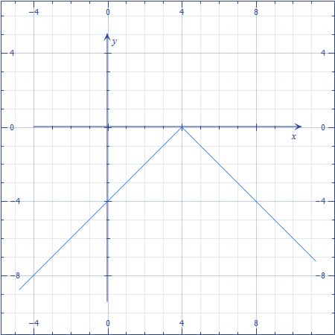 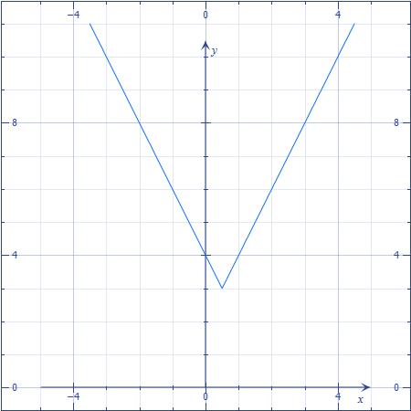

**16. Write the function rule $g\left(x\right)$ for the given transformations applied to the graph of $f\left(x\right)=x^{2}$. (L3)**

**4 units down, 1 unit left**

**16. g(x)=(x+1)2-4**

**17. Write two absolute value functions such that they have a common vertex in Quadrant III and one is the reflection of the other over a horizontal line. (L4)**

**17. sample: $f\left(x\right)=\left|x+1\right|-2$**

**And $g\left(x\right)=-\left|x+1\right|-2$**

**18. Graph the inequality: $2x+3y≥-6$**

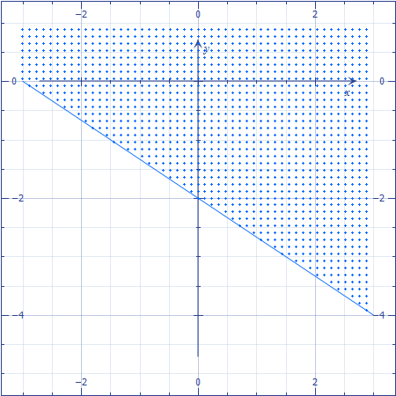 (L3)

**The table shows the enrollment at Coolsville High during the years 2004-2009.**

|  |  |  |  |  |  |  |
| --- | --- | --- | --- | --- | --- | --- |
| **Enrollment** | | | | | | |
| **Year** | 2004 | 2005 | 2006 | 2007 | 2008 | 2009 |
| **Enrollment** | 1582 | 1635 | 1674 | 1723 | 1745 | 1801 |

**19. Make a scatter plot of the data and draw a trend line. Let *x* = the number of years since 2003. (L2)**



**20. Write the equation of the line of best fit. (L3)**

**Answers will vary**

**21. Estimate the enrollment in 2015. (L4)**

**Answers will vary based on #20**

|  |  |
| --- | --- |
| **Learning Experiences** | **Text Pages/Resources** |
| **Vocabulary (Learning goals 1, 2, and 3)**   * Word wall * Foldable – See Glencoe @2010 Foldables by Dinah Zike for more information * Matching the word to the definition, graph, or example * Anticipation guide (pre and post) |  |
| * **Lesson Resources at the end of each section** * **Online Resources at pearsonsuccessnet.com** | Pearson  Algebra 2  Sections 2-1 through 2-8 |
| **General:**  **Test-Taking Strategy**  Be sure to check the reasonableness of your answer. If students are asked for the balance of a bank account where you were dealing with amounts in the hundreds, it is not reasonable to give an answer in the millions. To make sure the answer to a problem is reasonable, you can estimate before you calculate. If the answer is close to your estimate, your answer is probably correct. |  |

**Teacher Notes/Additional Resources**

**General Algebra & Math sites:**

* AlgebraLAB: Making Math & Science Connections [www.algebralab.org](http://www.algebralab.org)
* Classzone from Holt McDougall’s free site includes really cool animations. You and your students will simply need to figure out which chapter in their book relates to what we’re studying. <http://www.classzone.com/cz/books/algebra_1_2011_na/book_home.htm?state=NE>
* Kuta software <http://www.kutasoftware.com> Excellent free worksheets (with answers) <http://www.kutasoftware.com/free.html>
* NCTM’s Figure This! Web site has several challenge problems that are designed for families to do together. <http://figurethis.org/download.htm> These challenges (there are 80 of them!) could be used for daily warm-ups in class (several involve estimation), weekly Problem-of-the-Week, and even a challenge problem along with their homework, if relevant.
* Math is Fun! Includes an illustrated math dictionary and helpful tutorials for students. [www.mathisfun.com](http://www.mathisfun.com)
* Daily Math Review <http://www.aea11.k12.ia.us/E2T2/dmr.html>
* Great online timer: <http://www.online-stopwatch.com>
* Porta Portal’s consolidated resource list <http://guest.portaportal.com/mrburke>
* Algebra2Go <http://www.saddleback.edu/faculty/lperez/algebra2go/index.html>
* About.com Education site has great warm ups <http://712educators.about.com/cs/warmups/l/blwarmmath.htm>
* Southern Regional Education Boards Instructional Resources <http://www.evalutech.sreb.org/InstResources/index.asp>

**Books:**

* Various resources provided by publishers for the book selection process

**Videos:**

* BrainPop [www.brainpop.com](http://www.brainpop.com)
* Teacher Tube [www.teachertube.com](http://www.teachertube.com)